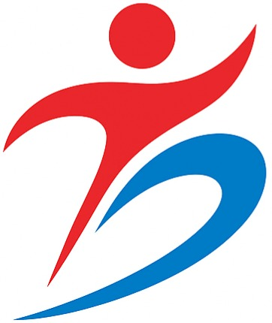
Product Catalogue 
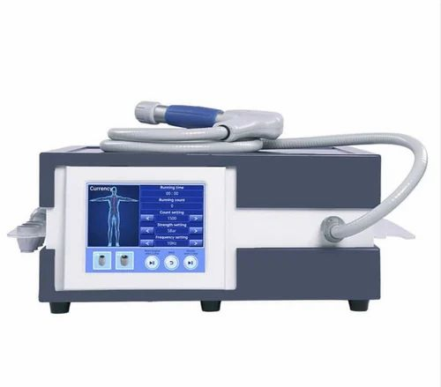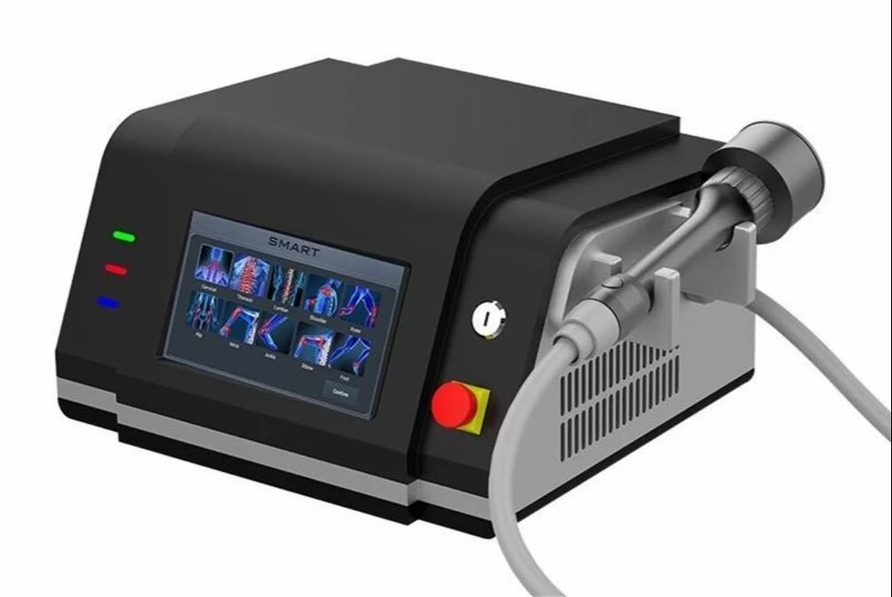
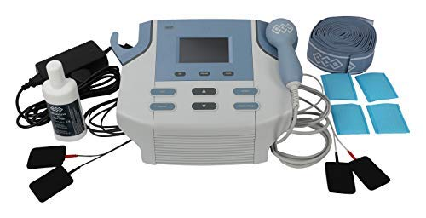
Shockwave Therapy Class 4 Laser Therapy

9009740116 9520241632

Combination Therapy

Regd.Off: 448 A 1st Floor Near Shree Ram Chowk Nyay Khand 3 Indirapuram Ghaziabad- 201014
E-mail: Healspringphysio@gmail.com

Combination Therapy/Electro & Utrasound Therapy
The BTL-4825SL PREMIUM is a high-tech 2-channel electrotherapy device with an extended current range. It also features a 1-channel ultrasound offering the latest industry-leading technology. With convenient body parts navigation, QUICK protocols, and portability with battery operation, it’s a versatile solution for effective physiotherapy and rehabilitation.
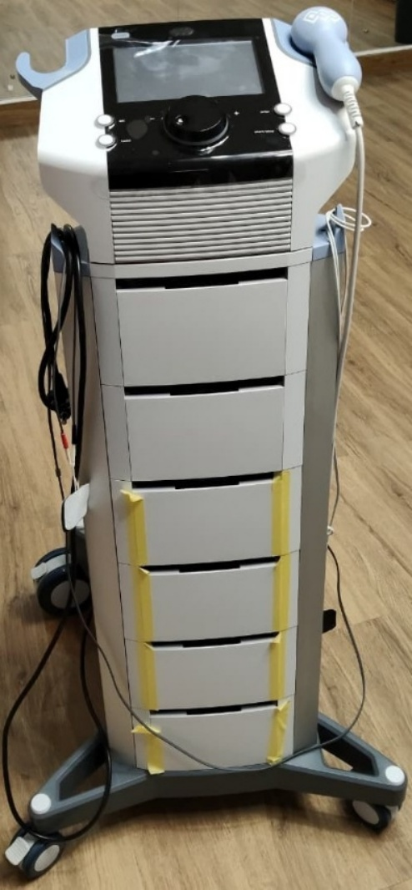
Main features of BTL-4825S Premium
• Large 7″ colour touch screen!`
• QUICK protocols
• Body Parts navigation
• Preset protocols and therapeutic encyclopaedia
• Patient database

ELECTROTHERAPY
• The largest range of waveforms available on the market
• Programmable sequences
• High Voltage therapy
• Constant Current and Constant Voltage modes
ULTRASOUND THERAPY
• Ergonomic heads with visual accessory identification / visual patient contact indicator
• Heated multi-frequency applicators: 1 and 3 MHz available
• Simultaneous treatment with 1 and 3 MHz
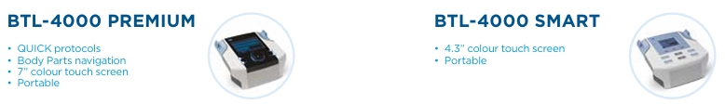
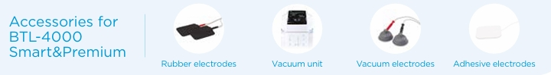
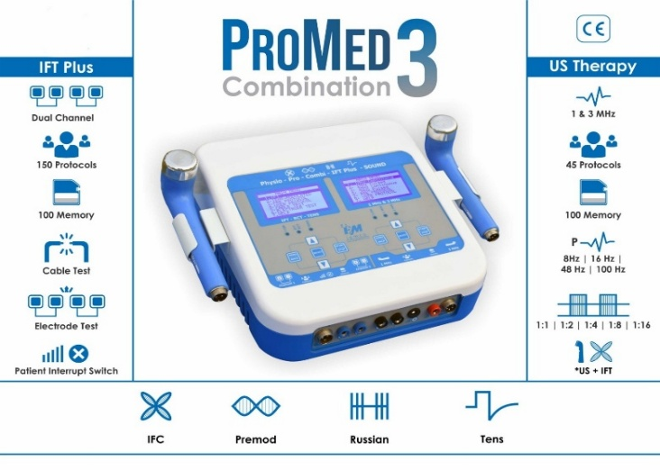
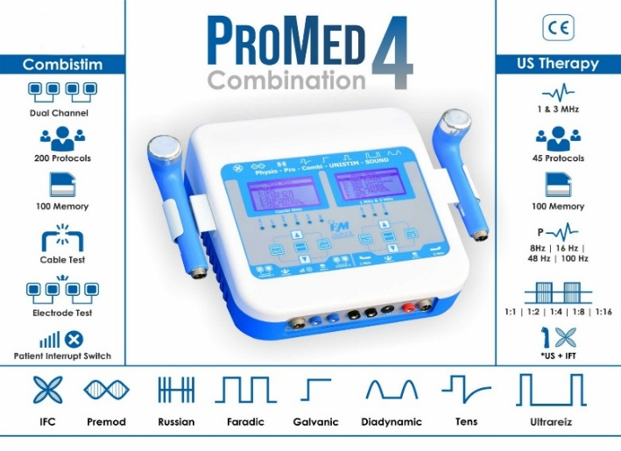
HOME VISIT PHYSIO KIT
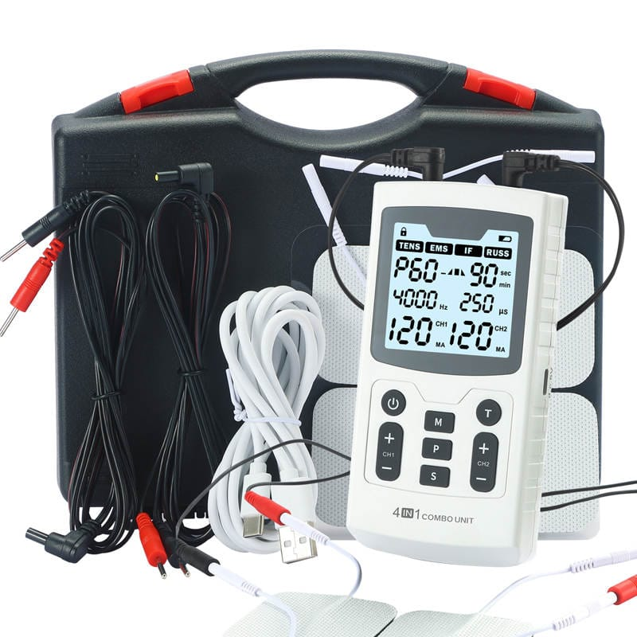
Physio TENS/EMS/IFT/RUSS Device (4 therapies in a device) IFT is Interferential Current. RUSS is Russian Stimulation. TENS and EMS belong to low frequency. The frequency is generally between 1-300 Hz. IFT and RUSS are belonged to medium-high frequency. The frequency between 2000-5000Hz

1. A total of 60 programs (Mode).
2. TENS：23 fixed + 2 adjustable programs.
3. EMS： 13 fixed + 2 adjustable programs.
4. IFT: 8 fixed + 2 adjustable programs.
5. RUSS: 8 fixed + 2 adjustable programs.
6. Adjustable intensity：0 - 120 levels. Max: 120mA.
7. Adjustable working time：5 - 90 minutes. 1min/step.
8. Mode and intensity of two-channel can be controlled separately.
9. Customers can adjust parameters according to their own needs
10. The frequency and pulse width of each program displayed on the display screen.
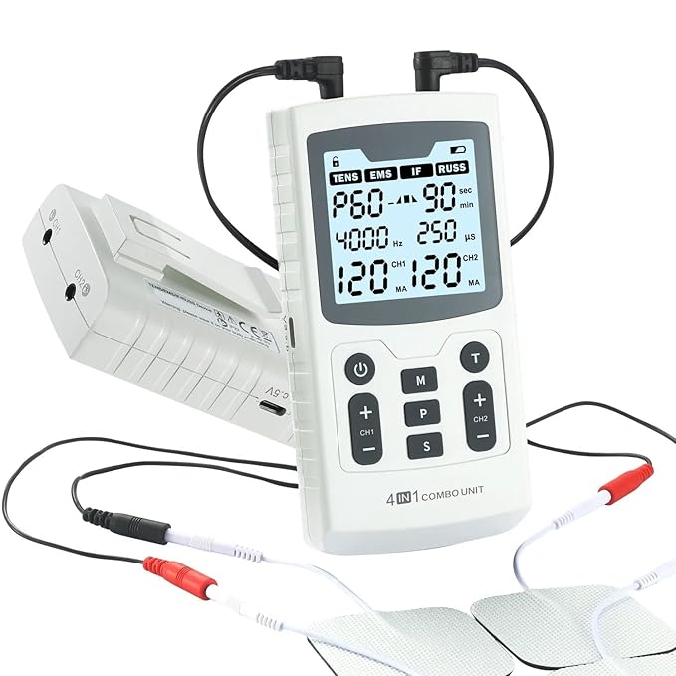
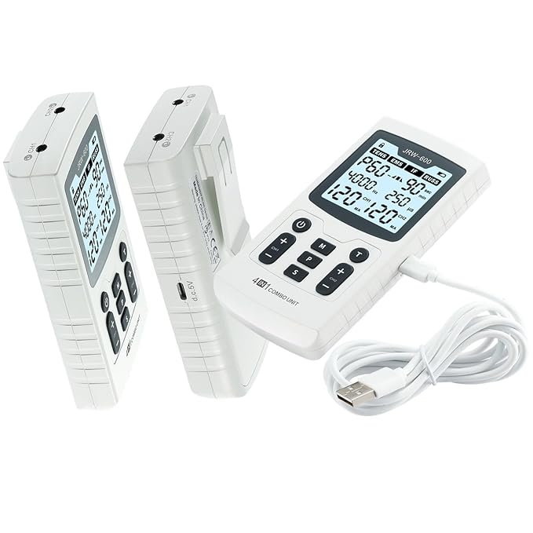
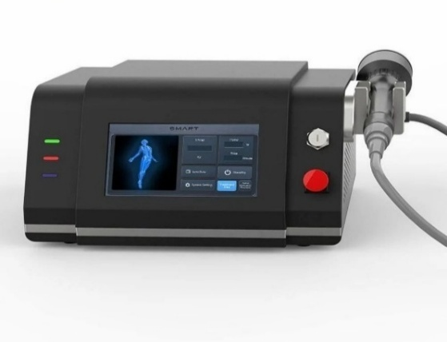  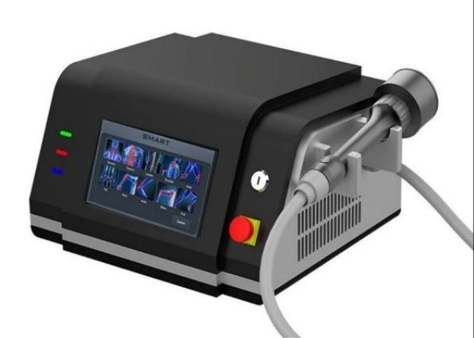  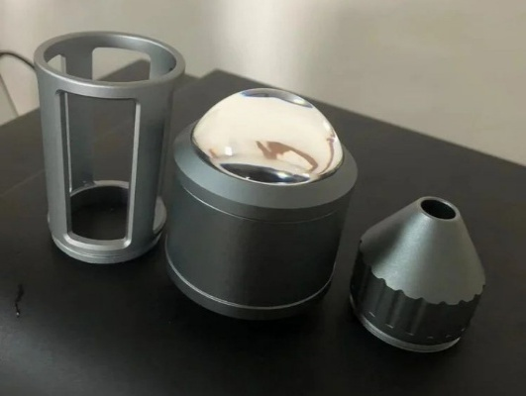 | Class 4 Laser Therapy Machine  is a powerful and professional-grade solution designed to deliver non-invasive, fast-acting pain relief. Engineered for use in physiotherapy clinics, chiropractic practices, and rehabilitation centers, this device utilizes high-intensity laser energy to penetrate deep into tissues, stimulating cellular activity, reducing inflammation, and accelerating the healing process.  With its wavelength technology (980nm), this advanced system is ideal for treating a wide range of conditions including chronic back pain, arthritis, joint pain, muscle injuries, tendonitis, and nerve inflammation. The device comes with a user-friendly touchscreen, pre-programmed therapy modes, and adjustable power settings, making it suitable for both new and experienced practitioners.  Safe, effective, and clinically tested, this Class IV Laser Therapy Machine offers a drug-free and surgery-free alternative to pain management-making it a smart investment for any professional healthcare setting.  Type Tabletop  Usage/Application Pain Relief  Material ABS Plastic  Brand China  Frequency 450 Hz  Wave Length 980 Nm  Features Class 4 Laser High Intensity Performance  Weight 5 kg
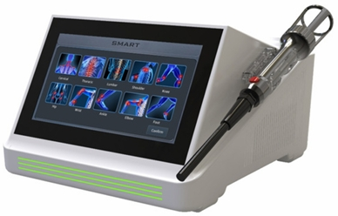  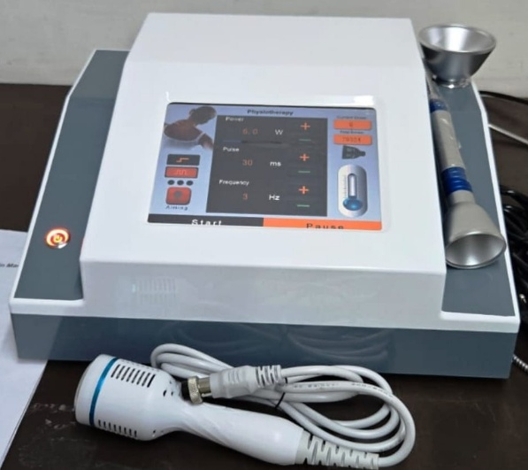 | Class 4 Therapy Laser  Experience the power of advanced laser therapy. TheBioTheraX-SuperLaser delivers deep tissue stimulation with a high-power 2080 mW output, ensuring faster recovery and pain relief. Designed for professionals, it combines precision, safety,and efficiency, ideal for physiotherapy, sports rehab, and clinical use.  Powerful performance. Reliable results. Premium design.  Laser Power - Up to 10W  Laser Wavelength - 980nm  Laser Type - Diode Laser  Screen Size - 10" HD Touch Screen  Operating Voltage - 220-240V

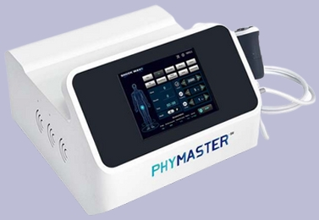
Extra Corporial Shockwave Therapy
Engineered for performance. The BioTheraX-AirShock is a heavy-duty pneumatic shockwave system built for busy physiotherapy centres. Its robust design, stable pressure output, and long service life ensure consistent, powerful treatments for deep tissue and chronic pain cases.
High power. Heavy-duty build. Professional results Shockwave Energy - 1 Bar to 10 Bar
Shockwave Freq. - 1 to 21 Hz
Screen Size - 8" HD Screen
Operating Voltage - 220-240V
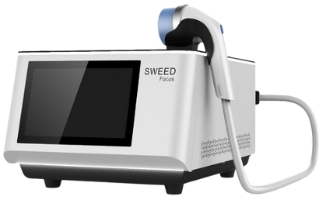
Focused Shockwave Therapy System
The BioTheraX-Focus delivers concentrated acoustic energy deep into tissues to accelerate healing, break down calcifications, and relieve chronic pain. Built for high-performance physiotherapy and rehabilitation, it offers accurate control, fast results, and exceptional patient comfort.
Focused power. Faster recovery. Proven results.
Penetration Depth - 0-70mm
Screen Size - 10.1" Android HD Touch Screen
Operating Voltage - 220-240V AC
Rated Power - 500W
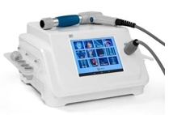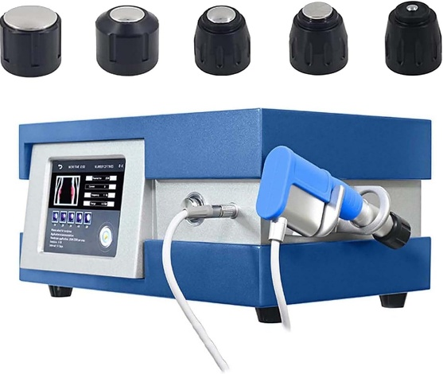  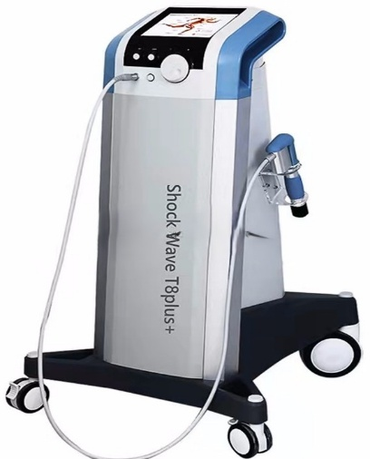 | Extra Corporial Shockwave Therapy Machine  Deep tissue pain relief for muscles, joints, and tendons  Chronic Pain & Injury Recovery: Helps reduce stiffness, inflammation, and muscle tightness.  Improves Blood Circulation: Promotes natural healing and faster.  Professional Physiotherapy Device: Suitable for clinics, sports rehab, and hospitals. Non-Invasive Pain Relief Therapy: Advanced treatment without surgery or medicines.  Heavy-Duty & Reliable Design: Built for continuous professional use.  Type Radial shockwave therapy  Usage/Application Hospital  Model Name/Number Q80  Brand Chaina  Product Type Pneumatic Shockwave Therapy Machine  Voltage AC 220V  Frequency 21Hz  Power 350W Max  Display Digital Touch Screen  Weight 12.7 Kg  Shock Limit Minimum 10 Lac Shock
EMG BIOFEEDBACK WITH FES AND GAMING SOFTWARE
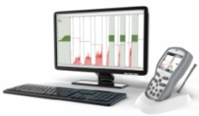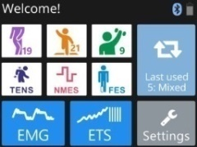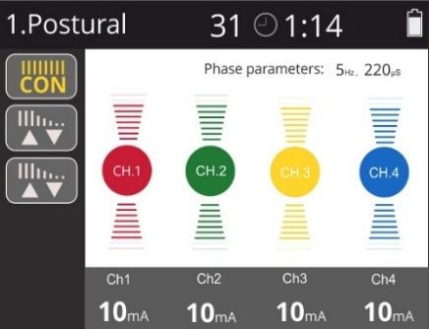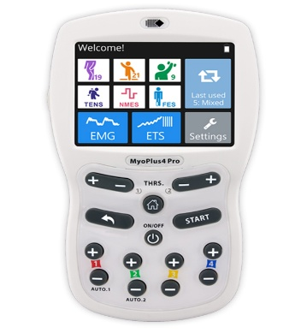
Myo Plus 4PRO, from Verity Medical U.K2 Channel EMG and 4 Channel NMES + ETS
Successfully used to treat conditions including Incontinence, Patellofemoral Pain, Myofascitis, Myofascial Pain, Phantom Limb Pain, Neck & Shoulder Girdle Pain and Repetitive Strain Injury.
Pre-set programs for Neuromuscular Rehab, Sports Rehab, Urology/ Gynaecology
EMG Triggered Stimulation mode (ETS) - is especially useful for stroke rehabilitation and Pelvic Muscle improvement. ETS is a combination of voluntary contractions with stimulation.
The graph shows the muscular report and the stimulation is triggered automatically to support the effort.
Urinary Incontinence
MyoStim+
The Biofeedback neuromuscualar stimulator KM 580 uses the principles of neuromuscular electrical stimulation and biofeedback therapy and has singificant therapeutic effects on patients with sports dyfunction and postpartum rehabilitating.
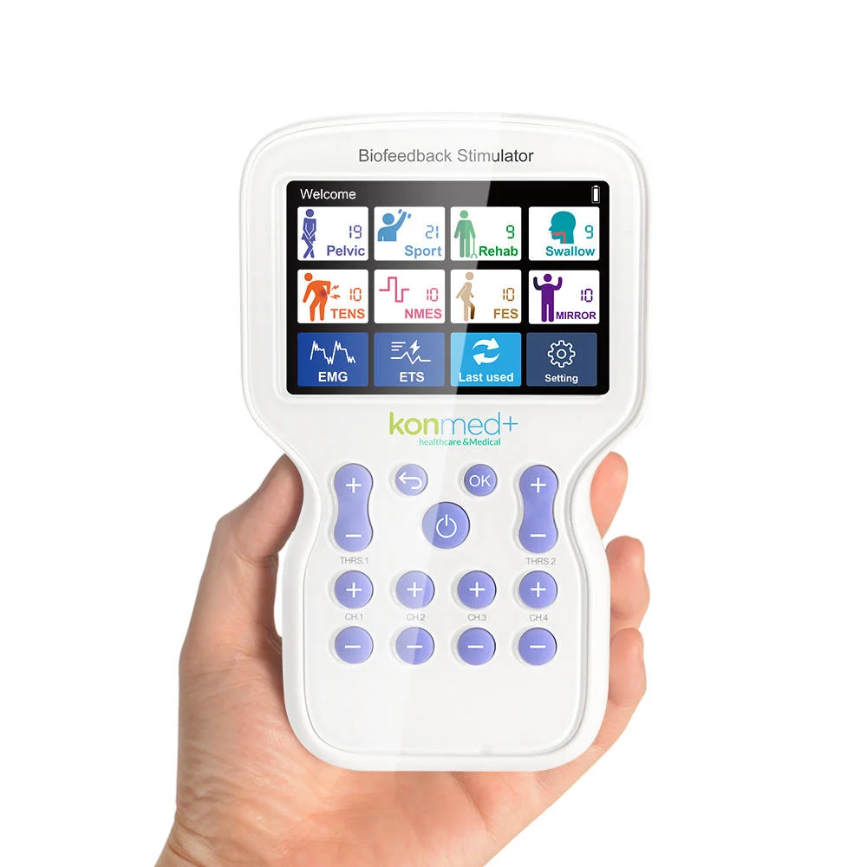
SPECIFICATIONS

EMG

2 EMG Test
1 EMGWork & Rest Training
5 Templates Traning
6 EMG Games
1 ETS

Mirror

10 Mirror Therapy modes

STIM

10 Pre-set & custom for Swallow
10 Pre-set and customer of TENS and Pain Relief
10 Custom modes for NMES
10 Custom modes for FES
3.5 Inch color touch display
Reachargeable
Dual Channel EMG ETS / Four Channel STM
Intensity 0-99 levels.

TECAR THERAPY
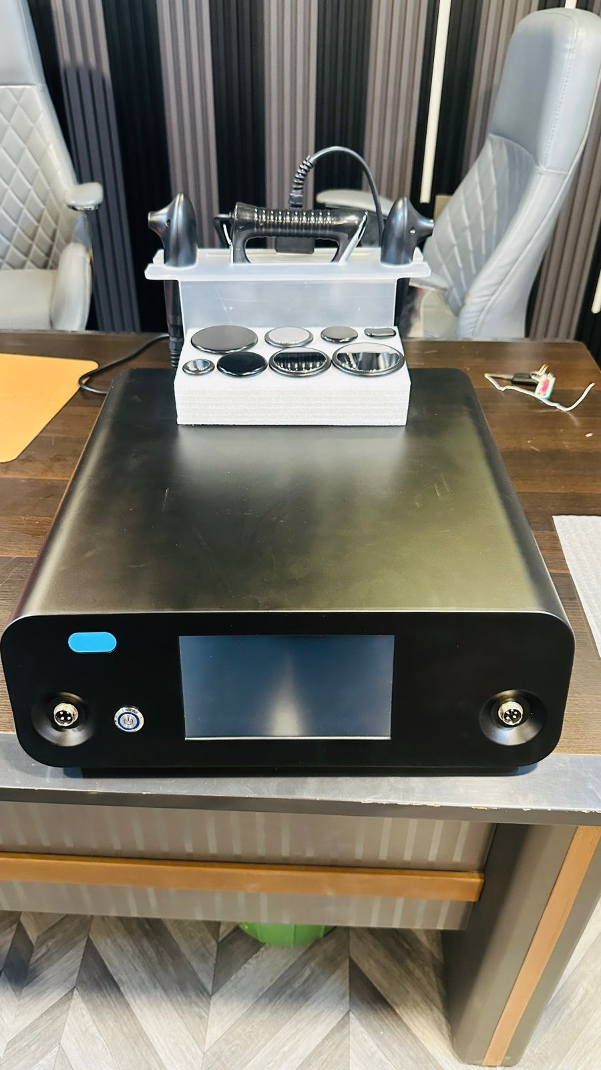
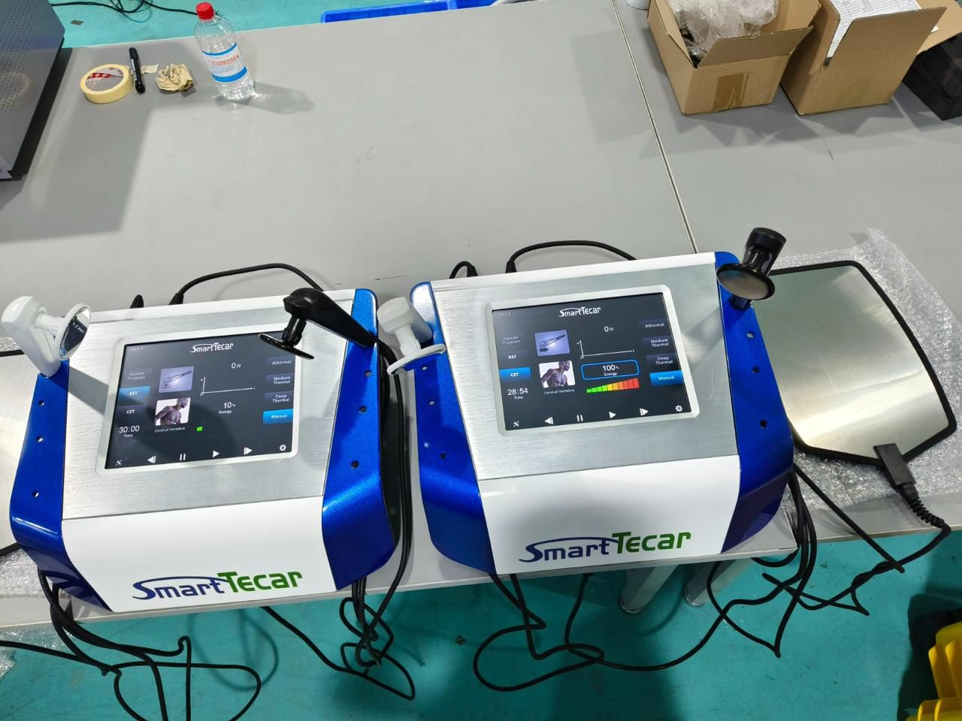
Easy to Operate: Quickly adjust treatment with capacitive and resistive modes.
Multi-Functional Beauty Device: Versatile device for skin tightening, fat reduction, and lymphatic drainage.
India Tecar|Indiba Tecar 448k|448K Tecar Therapy: Harness the power of 448K Tecar Therapy for rapid tissue repair and pain management.
Clinically Proven Results: Backed by clinical studies for effective face, neck, and body care.
Acrylic Material: Durable acrylic build ensures longevity and easy maintenance.

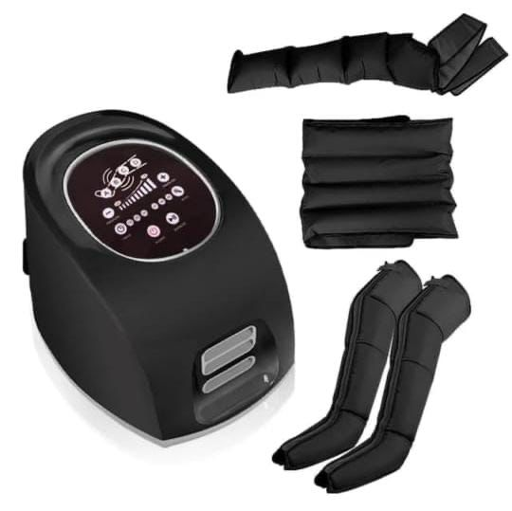
INTERMITTENT PNEUMATIC COMPRESSION THERAPY
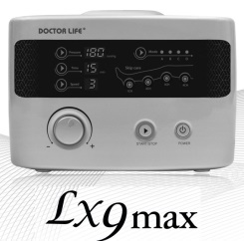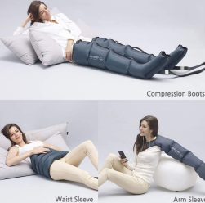
Lx9- Sequential Intermittent Pneumatic Compression System
4 chamber compression system with four massage programs
Mode setting: A-D
Pressure setting: 20-200 mmHg , Timing: Up to 90 Min , Skip Chamber function

HIGH ENERGY INDUCTIVE THERAPY (MAGNETIC THERAPY)
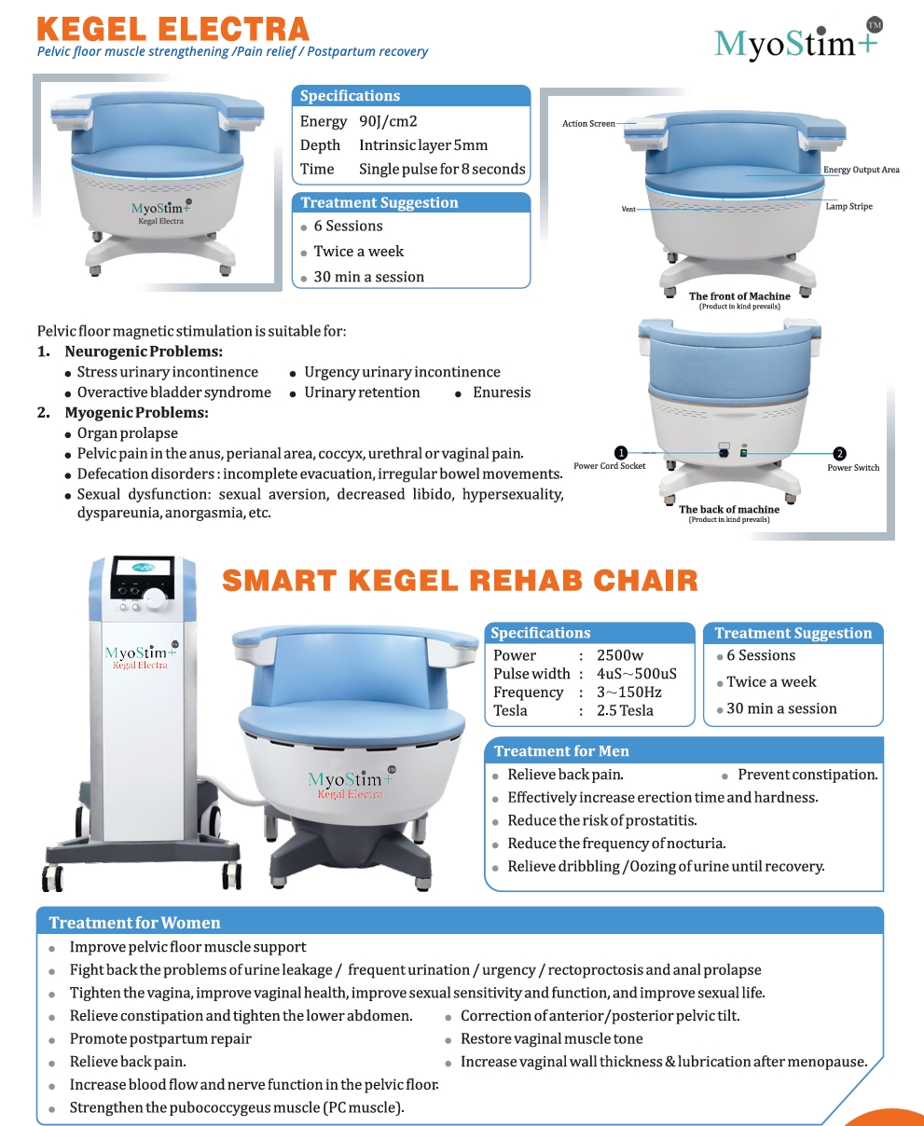
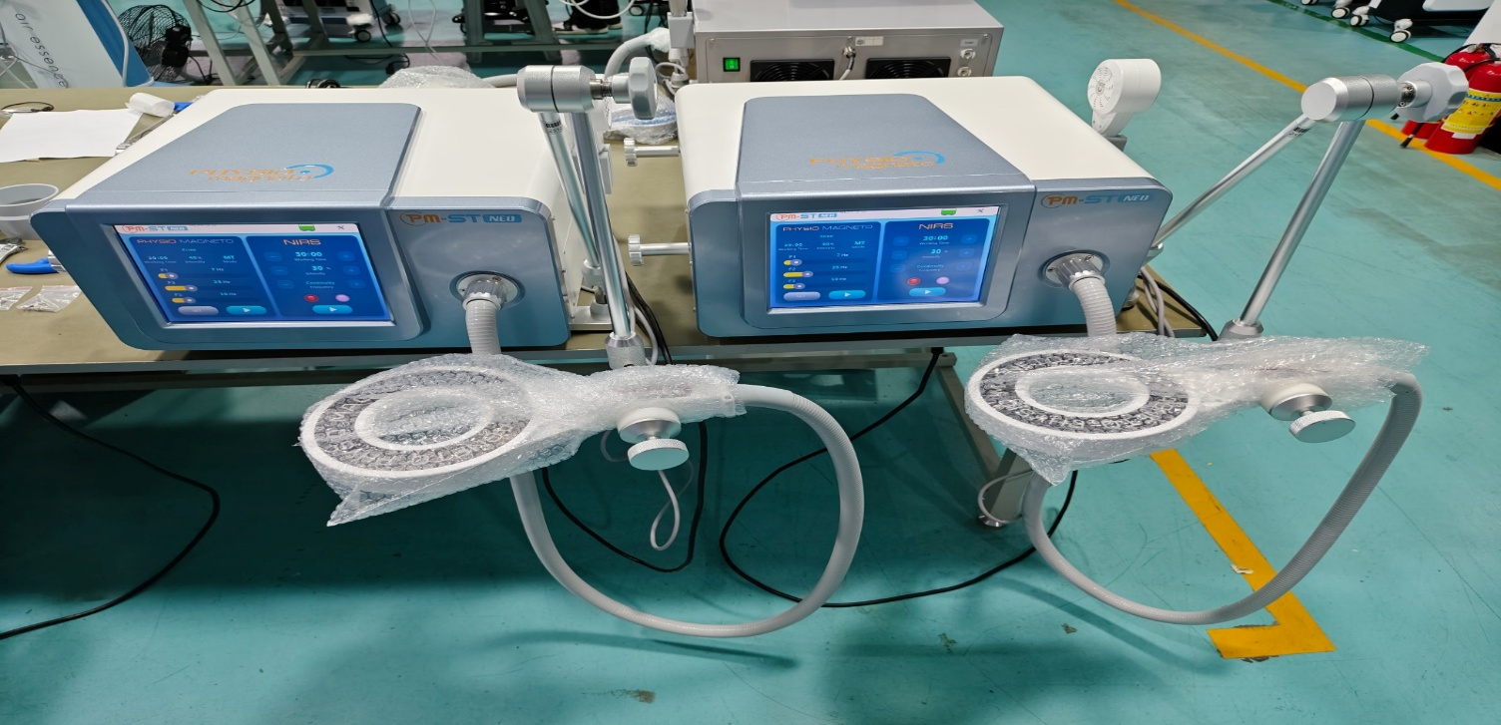
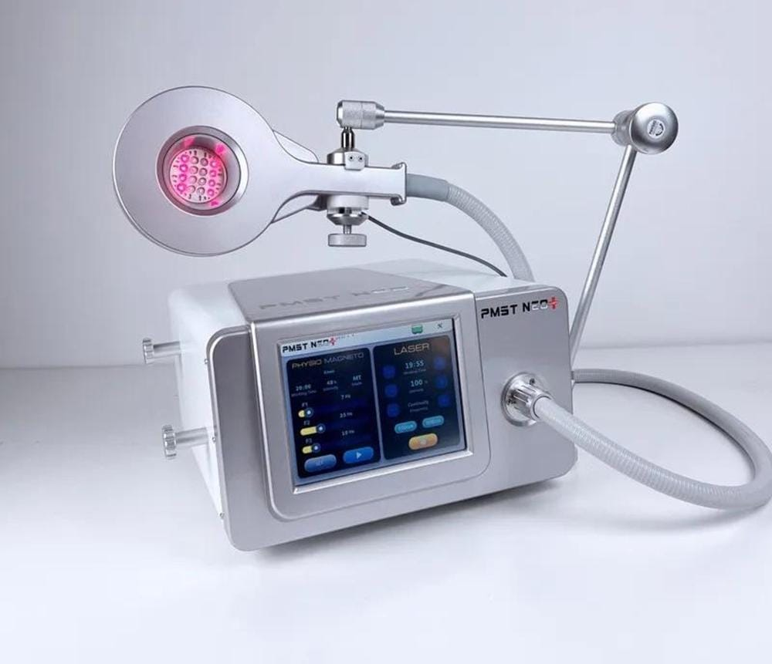
ELBO/ KNEE CPM/ Ankle CPM
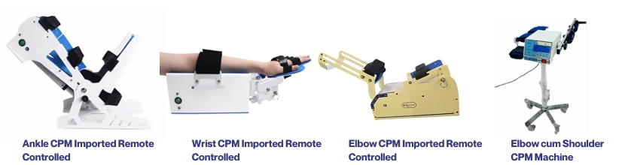
Elbow CPM assists in elbow joint recovery by offering simple range-of-motion adjustment.
This mechanical device ensures reliability without the need for intricate programming.
Customizable Range: Easily tailor the range of motion to each patient’s specific requirements.
Smooth & Quiet Operation: Designed for comfortable therapy sessions with minimal noise.
Sturdy Arm Support: Ensures secure positioning of the patient’s arm for consistent treatment.
Built to Last: Boasts a durable construction to withstand clinical use over time.
Benefits : Speedy Recovery: The device’s gentle, continuous motion accelerates post-surgery elbow
SHORT WAVE DIATHERMY
OUR PRODUCT IS COILE BASES TRANSFER IN HEAVY, 2 PC TRANSFER one pic for componrnt control ALL COMPONENT IS PHILIPS AND SAMSUNG USED AND HEAVT WIRE AND COIL OR BODY / USED FEQUENCY IS Generator Frequency – 27.12 MHz
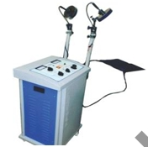
Pulse Wind -400 u sec
Continuous -500 W( Adj in 5 steps )
Pulse Frequency -50-500 Hz (10 steps)
Pulse -1000 W ( Adj in 5 step )
Time -0-99 min Digital Time
Power generation via a high efficincy microprocessor controlled, solid state amplifire
Fully adjustable pulse rate and pulse width
Selectable continuous and pulsed power modes
500 Watt in Pulsed mode
Automatic Resonance Tuning System
Automatic monitoring of distributed energy transfer to applicators
Modular desing easy assembling of applicators through modular sections and easy service process

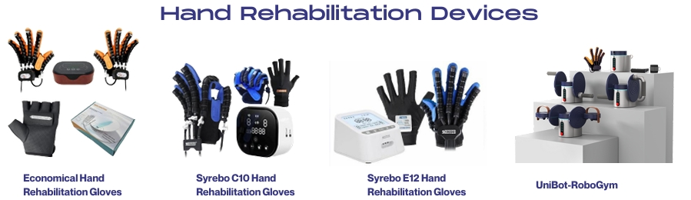
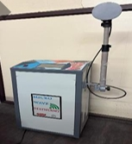
Microwave Wave Diathermy
Specification
Graphic 9 inch LCD TFT display
Integrated serial controller
microprocessors
Maximum power higher than 1600 W (in pulsed mode)
30 protocols stored in memory
Features
Size (LxHxD) 110 x 40 x 40 CM
Weight40kg
Power Voltage 230 V 50/60/Hz upon request 115V 50/50/60Hz
Absorbed power-900W
Fuse 6.3 A
Isolation classification I type BF
Degree of protection from liquids - IPXO
Power supplied - 250 W (Continuous) 1600 W (pulsed) 2500 CP

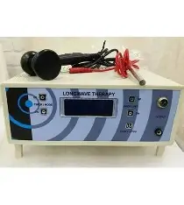
Longwave Diathermy
equipment is a computerised, used - friendly product manufactured by HMS. Longwave Diathermy machine is designed based on the capacitor field method It can work even during heavy voltage fluctuation. Longwave Diathermy can be used as alternative to Shortwave Diathermy Application. It is portable and
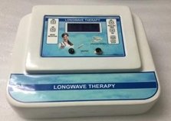
lightweight. Microcontroller based. Large LCD display. Touch free capsence keys. Plastic moulded light weight cabinet. Wide input voltage. Electrode size 30,50 &60 mm. Model: Spotcure Longwave diathermy. Operation Mode: Electrical. Usage: Clinical, Hospital Personal
SPECIFICATION. Output Frequency -1 MHz. Output Power - 1 Watt/100 Ohm. Adj. in 15 steps. Output Mode – Continuous / Pulsed. Output Wavelength- 300 meter. Pulse Freq. -100 Hz (4 Steps)
Display -128 x 64 Graphic LCD Display. Time -0-60 min
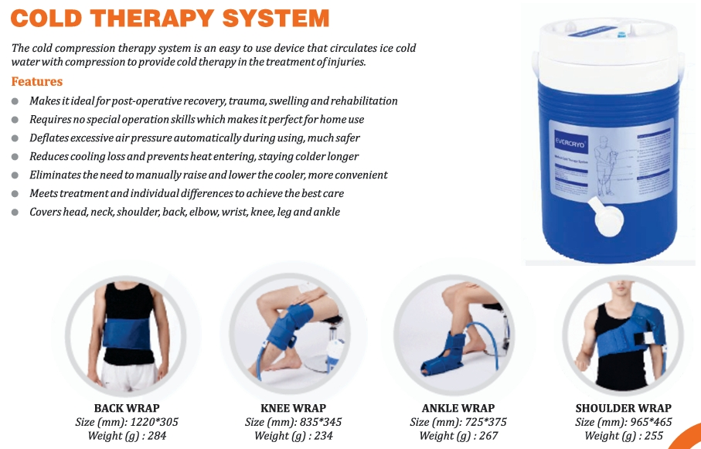
CRYO COOLING MACHINE
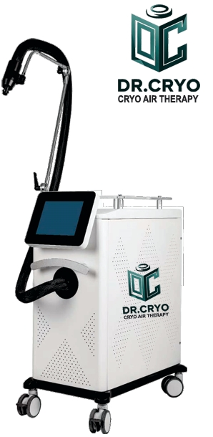
Skin surface pain relief
Cold Air Skin Cooling

The machine uses cooled air to effectively treat pain swelling and relax muscles. The system allows for precise targeting and cinstant diose cryotherepy every time. The device not any consumables and provides high power. This allows for rapid reduction of epidermal temperature while maintaining the ability to operate throughout the day.
Unlike other cooling methods, the machine can reduce skin temperature faster, reduce the risk of skin burns,and mainatain a constant dose throughout the treatment.
SOFTWARES
- Fan Setting - 1-9 levels
- Temperature - Displays tempareture
- Defrost - Aftre working continuously for about 2 hours,it can be used
- Cooling - Press to work
PARAMETERS
- Power 1600W
- Lowest Cooling Temp. -35°c
- Energy Mode 1-5 Levels Adjudtable
- Technology Refrigeration Technoligy
- Weight 73 Kg
PRECAUTION - Do not blow the same part for a long time to avoid frostbite.
- The height of the tuyere from the skin should be above 8 cm to prevent frostbite.
- When transporting, water must be released, and the inclination angle is not more then 30°
- Do not use alcohol to scrub the panel to prevent the handwriting from falling off.
- Don’t switch on frequentyl. The time interval between two boots should not be less than 3 minutes
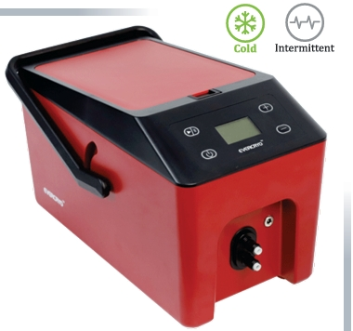
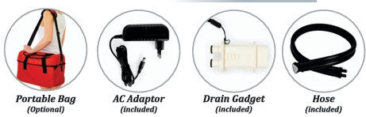
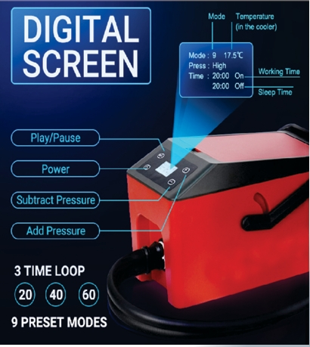
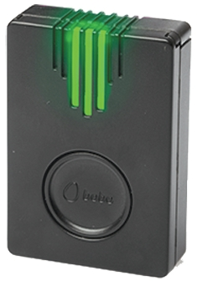
Bobo motion 2.0 / Vertual Reality
The Bobo motion is a wearable motion sensor that enables real-time measurement of a patient’s range of motion and provide expert guidance during exercise execution.
Specifications
- In the Box
- LED & audio indicators
- Sensors: 3-axis acceleromter, gyroscope
- Operating temp: 5°C to 45°C (23 °F to 113 °F)
- Wireless connection to tablets and smartphone
- Battery Tyep: Coin CR2032 3V – Non Rechargeable
- Battert Life : Approx 400 hours of continuous use
- Communication module: Bluetooth low energy (BLE)
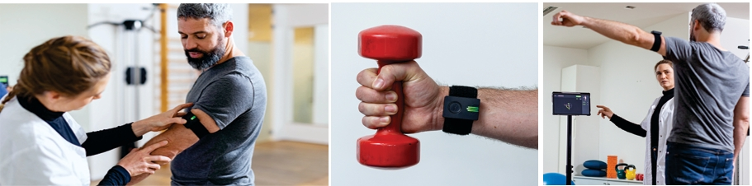
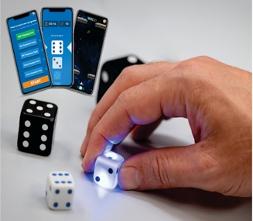
Bobo Dice
Smart Dice
Wireless connection to smartphone or tablet
Modules : Bluetooth low energy (BT5.0)
LED indicator : colorful lights system
Power : DC5.5V Super Capacitor + USB 5 VDC
Sensor : 3 axis accelerometer. 3D Sensor (contact less)
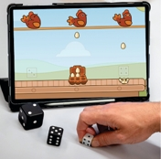
continuously track dice state
Manufacturer recommended age : 8 years up
Low power consumotion : 2h of play with a 10 sec charge
Material : High quality materials, Plastic ABS (dice)and SLA (dice shells
General Info :
- Package Weight : 200 gr
- D6 Weight : Big – 44 gr /Small -12 gr
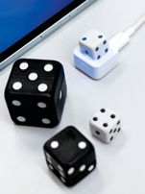
- Package Dimensiond : 18x5 12 cm
- Dice Dimensions : Big – 34mm / Small -24mm

BoBo Dice App:
- Requires iOS 13 and up or Android 6 and up
- Includes game, training evaluation and stats

COMPUTRIZED BALANCE TRAINER
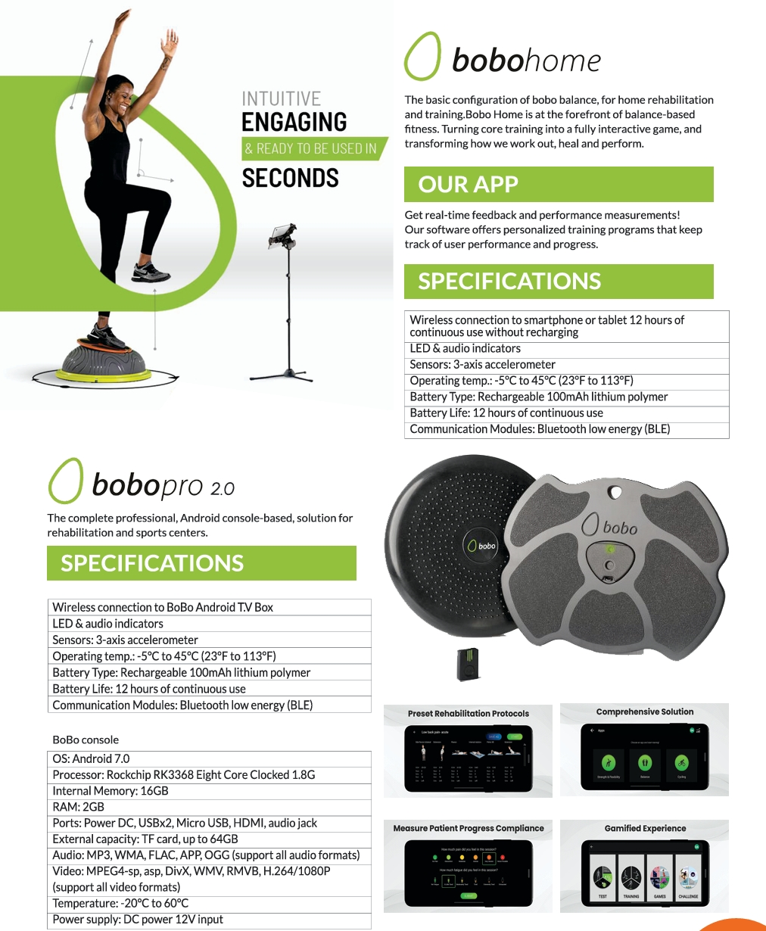* Premium wooden smart balance board (19.6" x 13.7") iOS/Android App with predefined training programs & 14 balance games
* Multiple patients dashboard
* Wearable Bluetooth motion sensor with 3 Velcro Straps
* ROM assessment and training
* Cycling speedometer trainer
* Holds up to 450 lbs
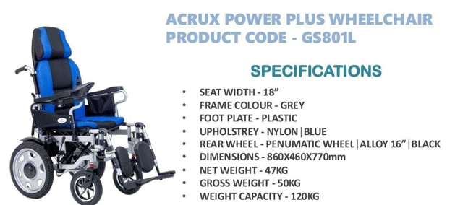
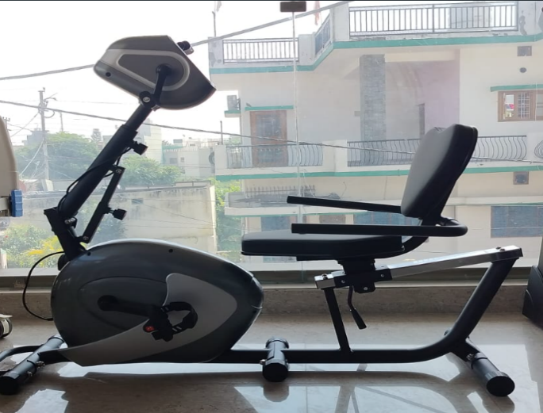
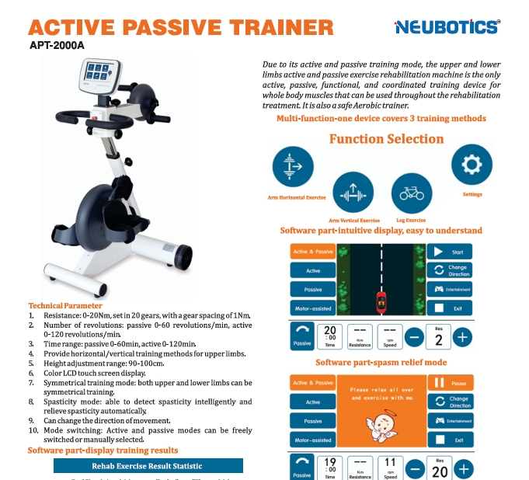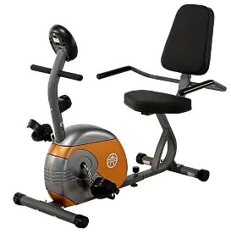
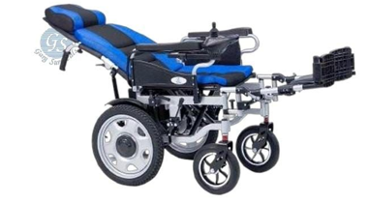
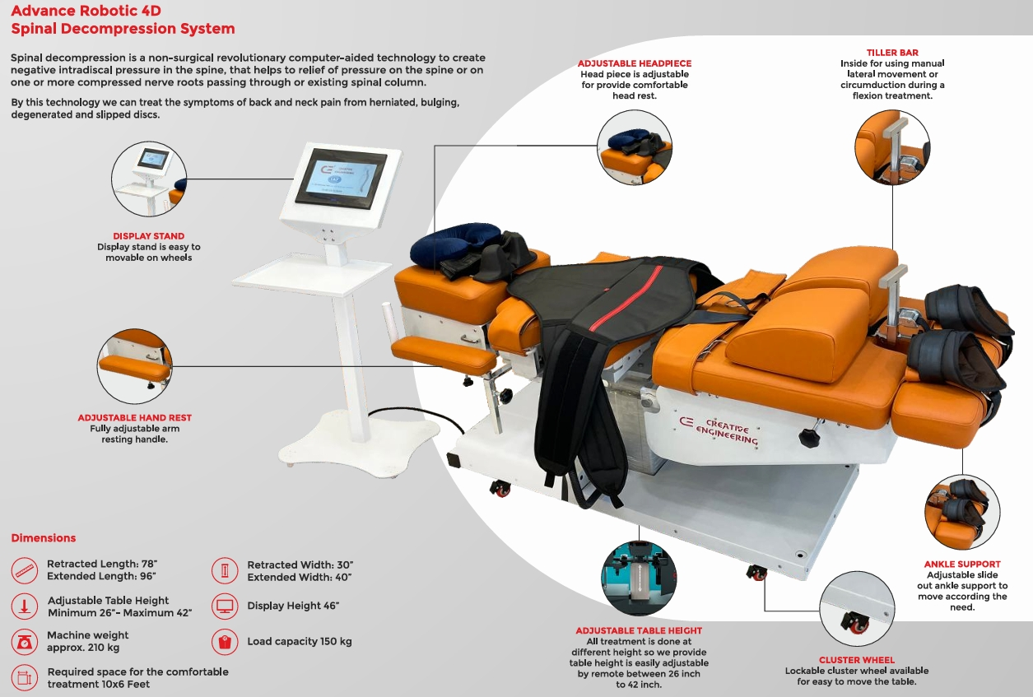
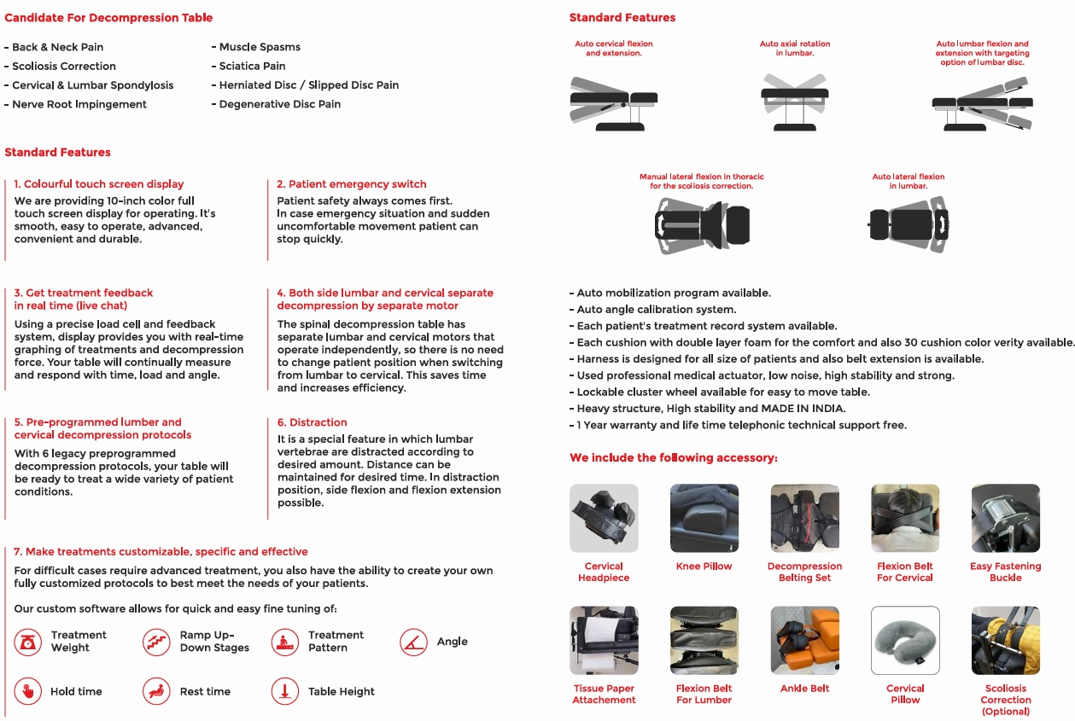
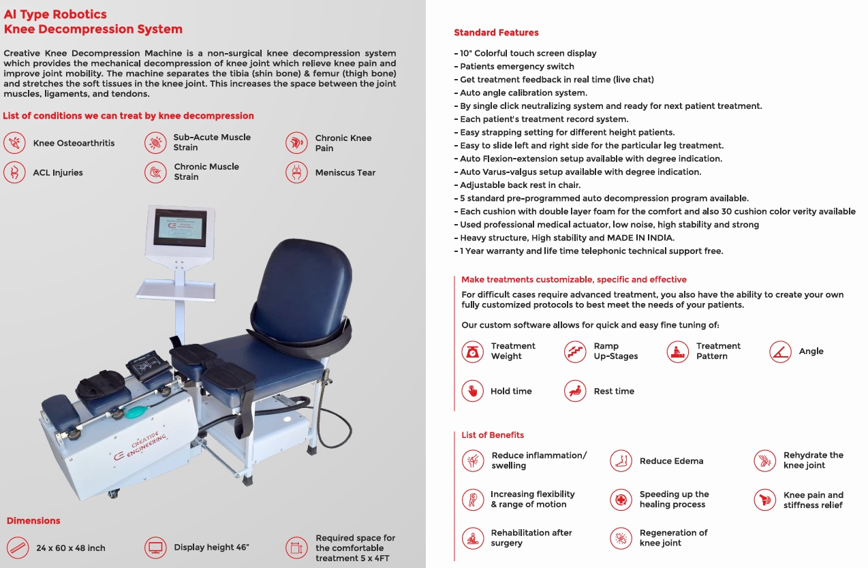
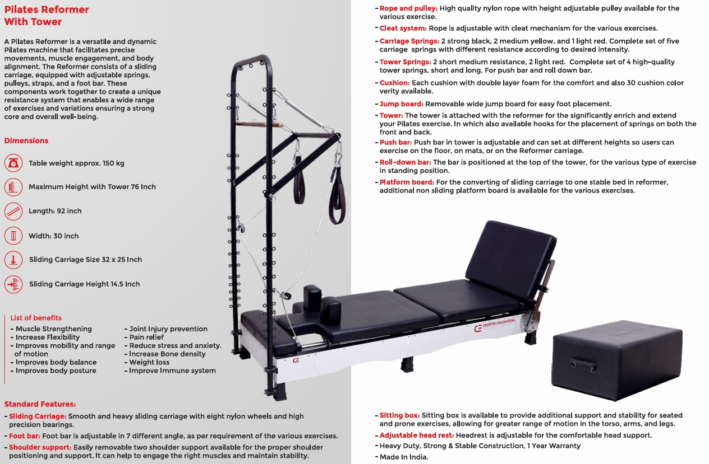
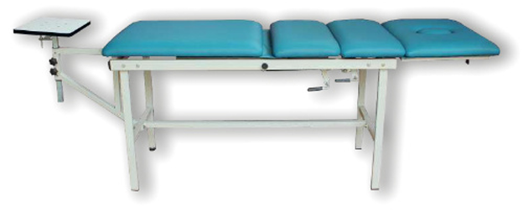
TRCTION TABLE
Four fold with pelvic traction sliding Adjustable backrest and foot section down Sliding section can we locked Contoured Face / Nose opening
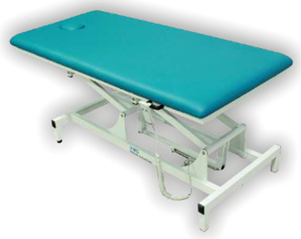
Traction fittings height can be adjustable MS with powder coated, Cushion Top with resin cover, Foot stool optional, Seamless rounded corner top, Easy bolt through- assembly, Table
BOBATH TABLE
Extremely Strong and rigid construction
Lifting capacity of 250 Kgs
Contoured Face / Nose Opening
Height Minimum 48 Cms – Maximum 110 Cms
Hand held remote control for high-low adjustable
All pivot points are fitted with bearing
Seamless rounded corner top
220V / 50Hz Table top size (L*W) - 200cm*73cm
Lifting Speed - 25 Sec. Approximately
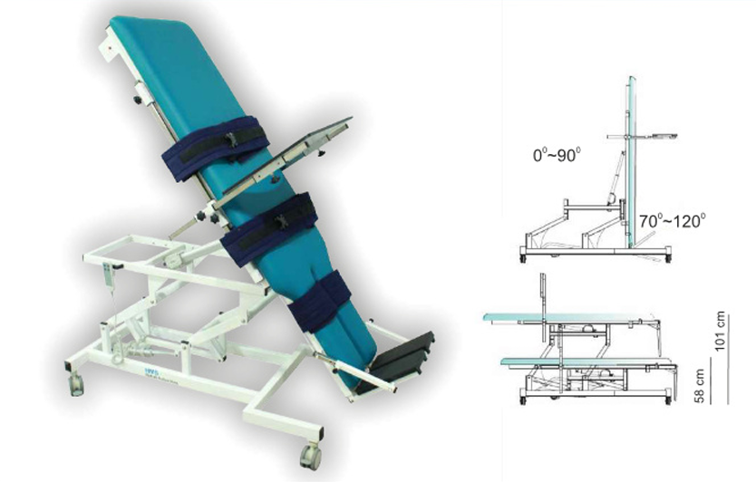
HIGH – LOW TILTING TABLE

HIGH – LOW TILTING TABLE Fully equipped for Rehabilitation and mobility purposes Electric height adjustments, easy to move with castors
Elevated frams to allow proper lifter positioning
Heavy duty motor lift up to 250 Kgs
Powder coated frames that prevents rusting and scratching
Remote control for up-down adjustments
Angle indicator
Three extra wide movable patient positioning straps with locking swivel casters
Removable foot rest
Safe working load with lifting and tilting capacity of 250 kgs
Electric height and tilting operation with hand switch control
Adjustable angle dual footboards-positive & negative (+15 to 30)
Worktable supplied with standard model-optional with economy model
Supplied with patient handgrips and set of harnesses
Height range 47cm to 101 cm (18-39”) Tilt angle from horizontal to 90 degrees vertical
Lowers to wheelchair height for ease of patient transfer
Tilt angle inclinometer fitted as standard
Purpose made precision bearings on all pivot points
Clearance beneath frame from for mobile hoist
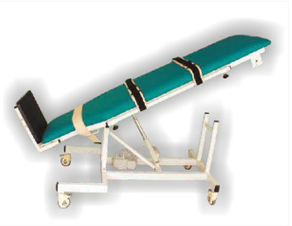
TILT TABLE
Elevated frames to allow proper lifting
Heavy duty motor lift up to 150 Kg
Powder coated frames that resist rusting and scratching
Remote control for tilt adjustment’s
Three extra wide movable patient positioning straps

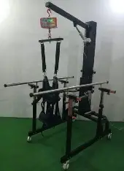
UN WEIGHING SYSTEM - GAIT TRAINER
Bewell Medicals GAIT TRAINING SYSTEM is used to reduce of whole body to lower limps of patient while thought hanging belts so as safety mainly used for those patients as arthritis lower limp’s disability pain and spasm caused by nervous system dysfunction and help patients walking function SPECIFICATION
Dual motor function Frame - Heavy duty metal
Remote control function Height of main frame - 225cm
Hanging scale for weight display Weighing capacity - 250kgs
Heavy duty lockable caster wheel, Hanging lifting range - 0-70 cm
Treadmill can be attached, Lifting mechanism - Electric DC 0perated imported motor
Life patient up to 200kgs, Recommended treadmill - Slow medical treadmill, Dimensions - 220V/50 Hz Operating voltage - L x B x H -100 x 110 x 225cm
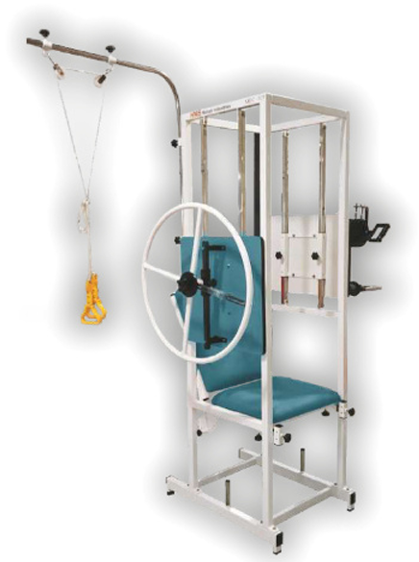
MULTI EXCERSER

Multi-function exerciser for those who don’t have more space. More than one exercise can do at time

Quadriceps
Shoulder pulley
Shoulder wheel
Finger ladder
Supinator / pronator
Adjustable back rest
MS Powder coating

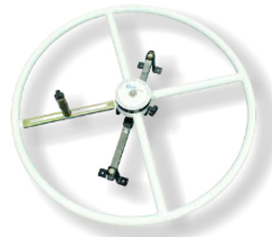
SHOULDER WHEELS DELUX & REGULAR
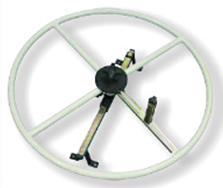
MS power coated Friction adjustable
Height can adjusted by a single knob
Easily adjustable hand
360`rotation with degree marking only in deluxe model
Tubular steel constructed wheel is fitted with resistance Mechanism
Resistance can be controlled, Diameter deluxe 90 cm, Regular 75 cms

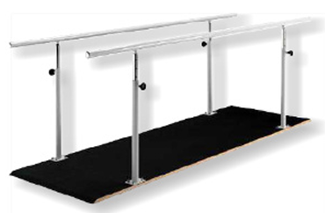
PARALLEL BAR WITHOUT PLATFORM PARALLEL BAR WITH PLATFORM
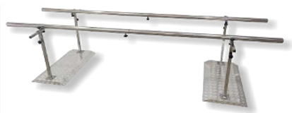
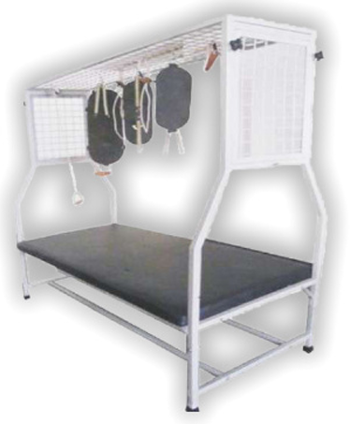
SUSPENSION THERAPY TABLE

FEATURES
Simple yet effective exercise pulley for upper arm & shoulders great for recovery after surgery or injuries for improving strength and mobility
Enhances range of motion for frozen shoulder or post recovery after surgery
Easy to assemble and store when not in use
Innovative pope length adjustment
The multi-use model features large handles with assistive grip

PODIATRY CHAIR
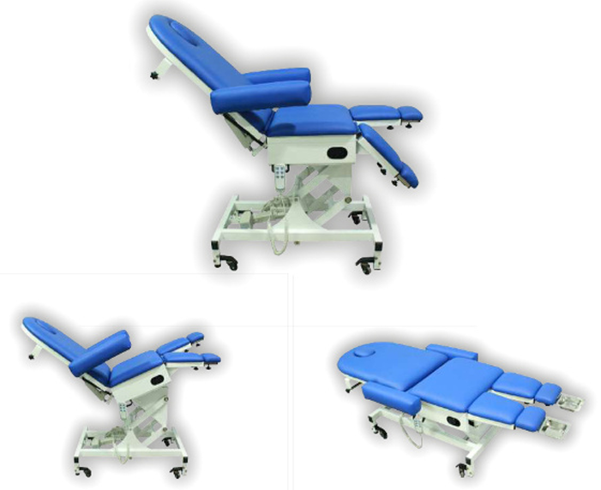
The electric podiatry chair is designed for biomechanics and multi-disciplinary use both in clinics and surgeries with the added benefit of motorized Trendelenburg seat tilt , greatly enhancing patient comfort
Examination / surgery chair
Comfortable stable frame
Reversible arm support
Height adjustable up to 100 cm
Five motor control with hand / foot control (or)
Three motor control with gas spring control for leg
Leg length adjustable
Upholstery colour choice
Adjusted to flat table position

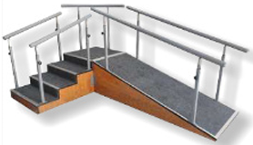
TRAINING STAIRS
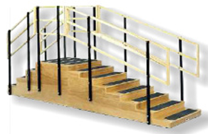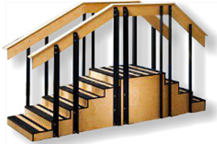

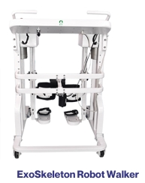
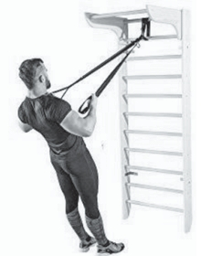
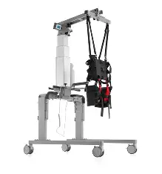
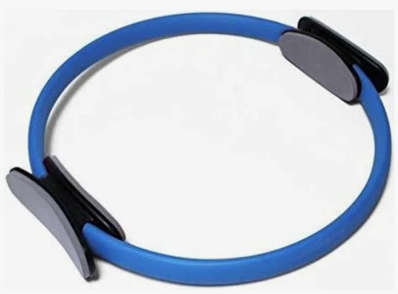  Pilatis Ring | 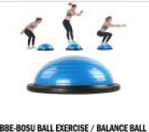  Half Balance Ball  ( Boso Ball ) | 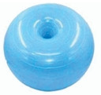  Donut Ball | 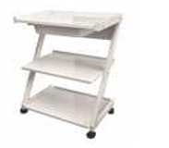  Z Trolley
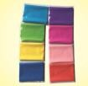  Theraband Set | 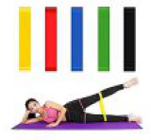Thera Loop Set |  |  | 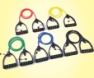  Thera Tube Set | 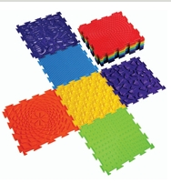  Sesory Mat Set Of 10
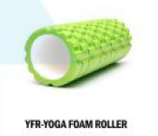 Thera band Roller | 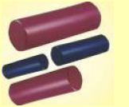  Bolster Set |  | 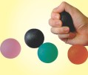  Gel Ball |  | 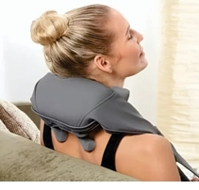  Nack Massager
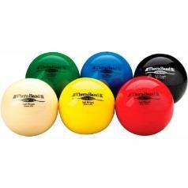  Soft Ball | 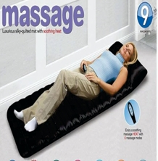  Massage Bed |  | 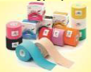  Kinesiology Tape |  | 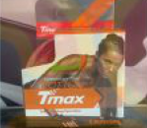  T max Tape
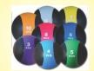  Medicine Ball | 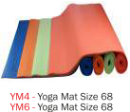 Yoga Mat |  | 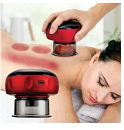  Cupping Massage |  | 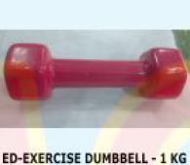  Dumbbells
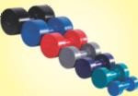  Dumbbells | 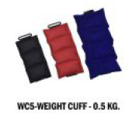  Weight Cuff Set 500gm/1Kg/2Kg |  | 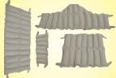  Hot Packs All Size |  | 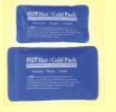  Cold Packs
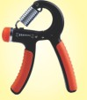  Hand Spring | 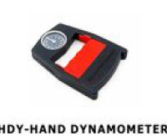Hand Dynamometer |  | 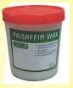  Paraffin Wax |  | 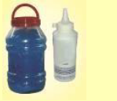  Ultrasound Jar  5Kg & 250gm
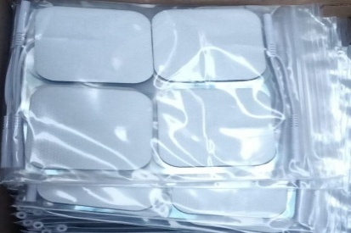Adhesive Electrode  ( Pad ) | 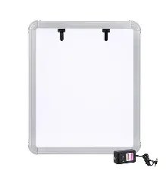  X-Ray Viewer |  |  | 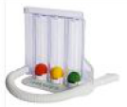  Spiro metre 3 Ball | 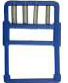  Finger Excersize
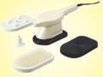  China Massager | 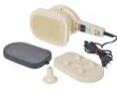  Indian Thrive Massager |  | 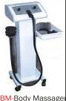  G-5 Massager |  | 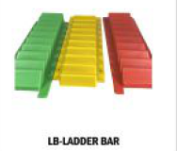  Finger Ladder
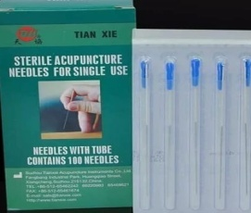  Dry Needle Tian All Size | 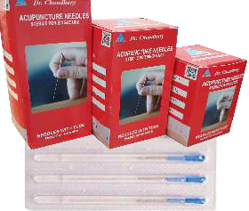  Dry Needle Dr. Chaudhary 13*25MM Size |  |   Dry Needle Dr. Chaudhary 25*25 Size |  |   Dry Needle Dr. Chaudhary 25*40 Size
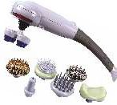  Magic Body Massager | 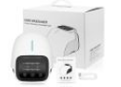  Knee Massage Vibrator |  |  | 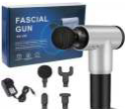  Massage Facial  Gun | 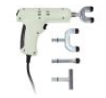  Chiropractic Gun
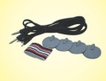  Carbon Electrode  ( TENS Pad ) | 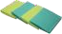  Sponge |  |  | 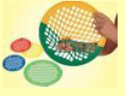  Finger Power Web | 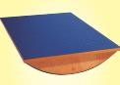  Wooden Balance Board
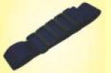  Muligun Belt | 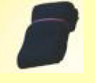  StrapVelcrow |  |  | 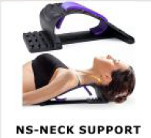  Neck Support | 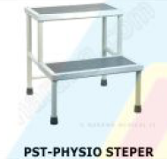  Physio Steper
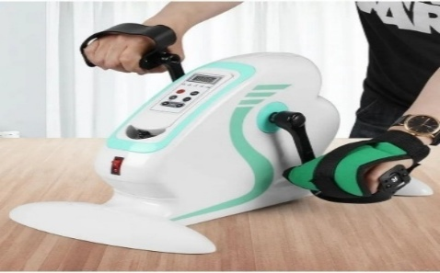  Pedo Cycle | 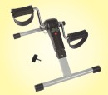  Pedo Cycle |  |  | 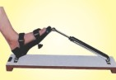  Heel Exerciser | 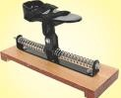Ankle Exerciser
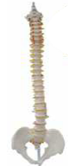  Spine Model | 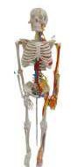  Human Skeleton |  |  | 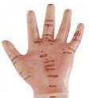  Hand Model | 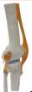  Knee Model
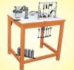  Hand Excerciser Table | 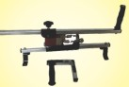  Axial Shoulder Wheel |  |  | 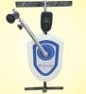Motorized Shoulder Wheel | 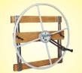  Wall Mounted Shoulder Wheel
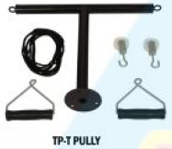  Shoulder Wheel | 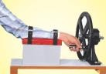  Wrist Rotator |  |  | 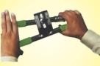  Hand Exerciser | 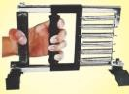  Grip Exerciser
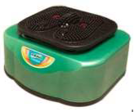Oxygen & Blood Circulation Machine | 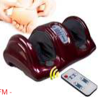  Foot Massager  Half |  |  | 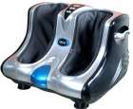  Leg Massager | 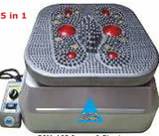  Oxygen & Blood Circulation Machine Deluxe
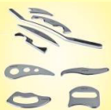  IASTM Tools | 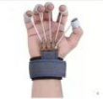  Finger Forearm Exerciser |  |  | 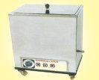Hydrocollator Hot Pack Machine | 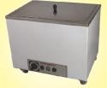  Paraffin Wax Bath
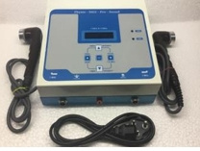 ULTRASONIC 1 & 3mhz with IFT FEQUENCY | 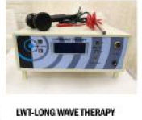  Vacuum Therapy Machine |  |  | 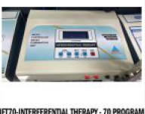  70 Program | 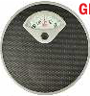  Weight Machine
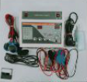  Ultrasound & 4 Channel TENS | 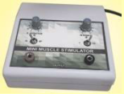  Mini Muscle Stimulator |  |  | 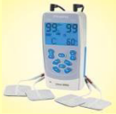  Pocket TENS | 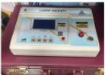  Laser Therapy
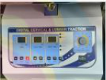  Traction Therapy | 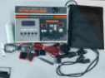  Machine 5 in 1  IFT, MS, TENS, US, DEEP HEAT |  |  | 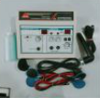Ultrasound & 2 Channel TENS | 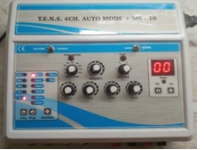  4 CH AUTO MODE TENS / MS 10
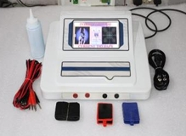  IFT TOUCH IMPOTED KIT | 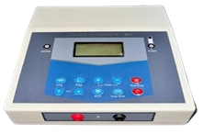 Muscle Stimulator IMPOTED KIT |  |  | 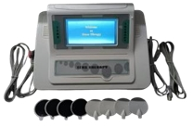  TENS 4 CH TOUCH IMPOTED KIT |  | 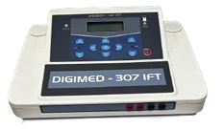  IFT IMPOTED  KIT
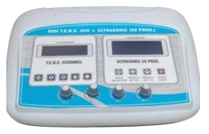  4 CH TENS LCD + ULTRASONIC 50 P  ROGM 1 MHZ | 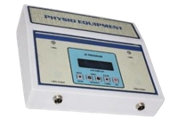  Ultrasonic therapy unit -1 &3 Mhz | 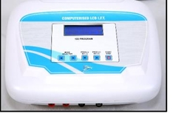  IFT 125 P |  |  |  | 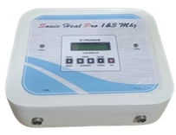  1 & 3 MHZ ULTRASONIC
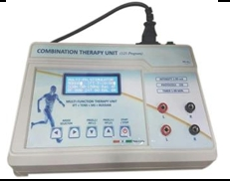  Multi-function therapy Unit IFT+TENS+MS +Russian | 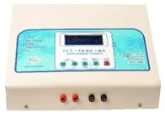  IFT 125 PRO METAL & PLASTIC BODY BOTH | 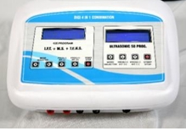  4IN1 IFT /TENS /MS /US 50 P |  |  |  | 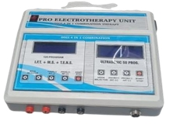  4IN1 IFT 125 P / US 1 MHZ
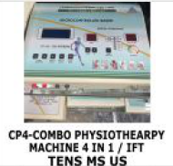  Combination Machine 4 in1 IFT, TENS, MS, US | 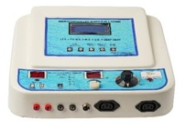  5IN1 ( IFT ,TENS,  MS 125 P/ HEAT/  US 1MHZ | 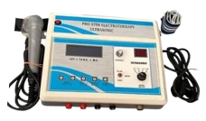  4IN1 IFT 125 P / US 1 MHZ |  |  |  | 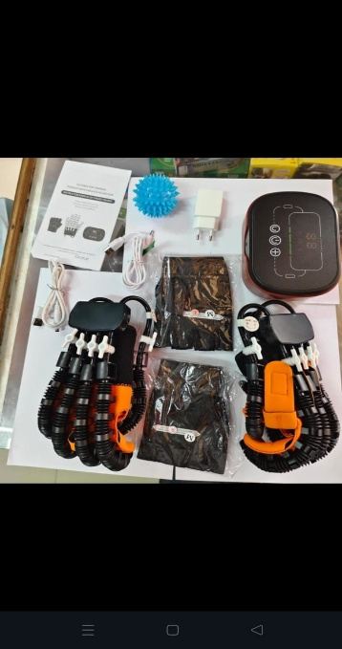
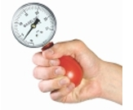  Squeeze Dynamometer | 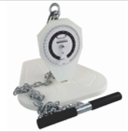  Bak Leg Dynamometer | 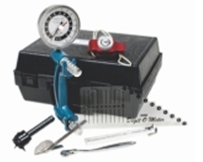  7 pcs Evaluation Kit |  |  |  | 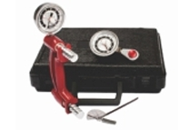  3 Pcs Evaluation Kit
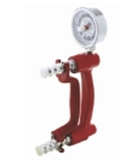  Hand Dynamometer | 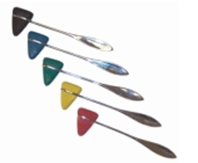Percussion Hammer | 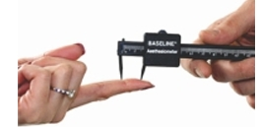  Two Point Discriminator |  |  |  | 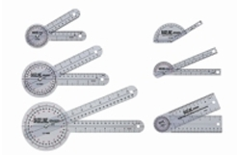  Goniometer
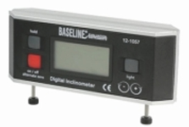  Inclinometer | 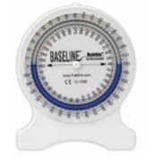  Bouble Inclinometer | 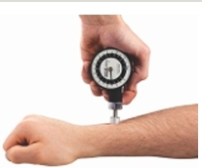  Algometer |  |  |  | 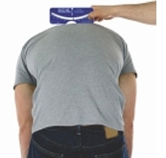  Scoliometer
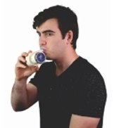  Dry Spirometer | 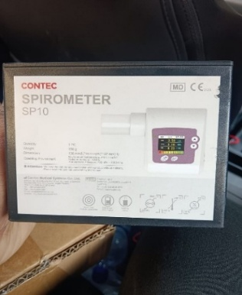  Computrized Spirometer | 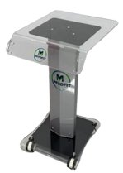  Machine Trolley |  |  |  | 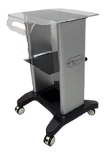  Machine Trolley
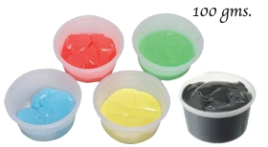  Therapy Putti | 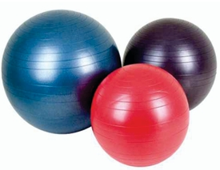  Exercise Ball | 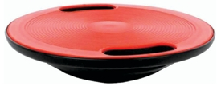  Bobble Board |  |  |  | 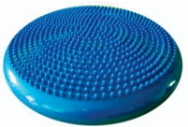 Balance Disc
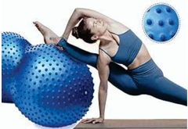  Peanut Ball | 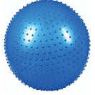  Sensory Ball | 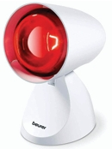  Infra Red Lamp |  |  |  | 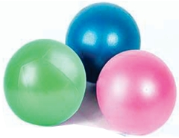  Pilatic Ball
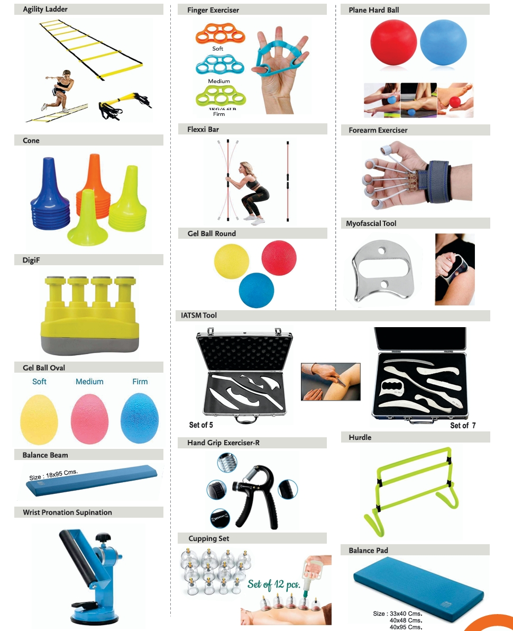

FULL BODY MASSAGE CHAIR
